As the Easter ‘break’ is approaching you may be looking for some ideas to keep your children occupied and calm their worries. Our children are struggling with not seeing their friends, as much as are we, and it is important that us adults share this with them. They are also worried about what they are hearing on the news and around them and hopefully these ideas can help you to share these concerns. Remind them, this is a tricky time but we are doing it to stay safe and we will get through it together.
Take care of yourselves and your families from all of the team at Saint John Houghton Catholic Academy.
Gratitude Jar
What are you grateful for? Add something new every day.
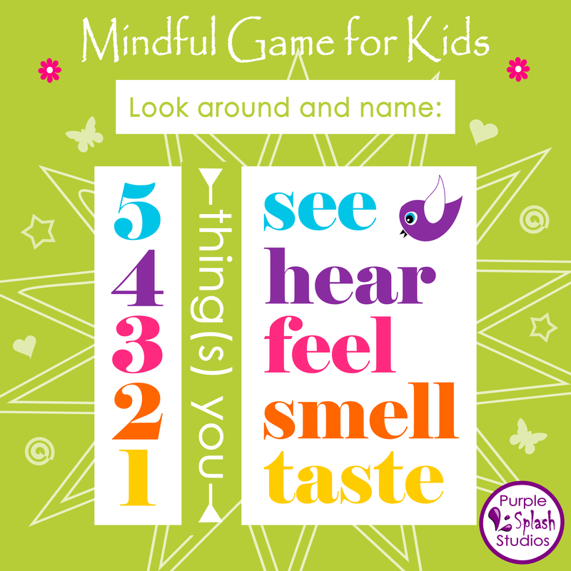https://www.smilingmind.com.au/thrive-inside https://www.childline.org.uk/toolbox/calm-zone/

https://www.youtube.com/user/CosmicKidsYoga https://www.youtube.com/watch?v=K7FUbTac_ds&vl=en-GB

Make a note of all the things you want to do when life goes back to ‘normal’. Share them and their importance before putting them in a jar ready to get them out and do them soon!

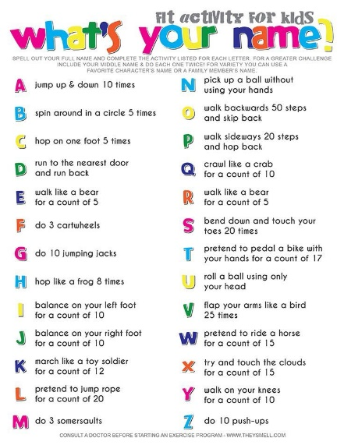
Make a family play-list of your favourite feel-good music – share memories of the music and dance together

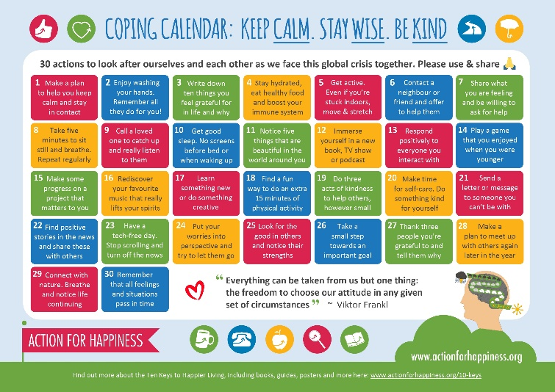

https://www.actionforhappiness.org/media/863032/coping_calendar.jpg
Contact someone you care about every day- this could be by phone, letter, WhatsApp, Skype… whatever you have available. This connection is very important for us all!

