During this time of uncertainty parents are feeling overwhelmed by the prospect of homeschooling. Some of you are attempting to work from home, support your children through this difficult time and keep up with their education. Don’t stress about educating them. Cuddle up, read, do a puzzle, build a fort, bake, watch TV together, paint, get out the lego and build together – just spend time together. Your kids won’t learn much if they are stressed. Play is a wonderful way of keeping you and your children emotionally regulated through unsettling times. During this period of isolation, celebrities are also doing their bit to help educate your children (and give you five minutes!) by holding virtual classes. Below are some ideas to add to your daily schedules along with some websites you might find useful. Take care of yourselves and your families from all of the team at Saint John Houghton.
PE with Joe Wicks.
The ‘Body Coach’ is getting kids moving with his home PE lessons Monday – Friday from 9am. Take part by heading to ‘The Body Coach TV’ on You Tube.
Music with Myleene Klass
Myleene wants to pass on her love for music, teaching your child rhythms, how to read music, making instruments and having fun Mondays at 10am, Wednesdays at 6:30PM and Fridays at 10am. Take part by heading to ‘Myleene’s music Klass’ on You Tube.
Story Time with David Walliams
David Walliams is releasing a free audio story every day for 30 days, reading out stories including his own book ‘The Terrible Triplets’. Check these out at https://www.worldofdavidwalliams.com/elevenses/
Dancing with Oti
Oti Mabuse (From Strictly Come Dancing) will be doing a free dance class on her Facebook / Instagram pages at 11:30am.
Cooking with Theo Michael (former MasterChef star)
Young chefs can tune in to Theo’s cook-along every Monday, Wednesday and Friday at 4pm on instagram@theocooks.

Wildlife with Steve Backshall – Steve will be live on his facebook page answering wildlife, biology, conservation, geography and exploration questions.
Science with Brian Cox – Keep up with Brian on his Twitter as he has plans to bring Science teachers to you, answering questions about black holes, viruses and the moon from children.
Some ideas for inspiration…
100 things to do indoors by Shonette Bason Wood

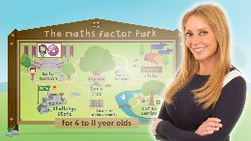
Carol Vorderman is offering free maths lessons https://www.themathsfactor.com

Twinkl- free access to all teaching and learning materials
www.twinkl.co.uk
30 day lego challenge
https://www.freehomeschooldeals.com/free-printable-30-day-lego-challenge-instant-download/
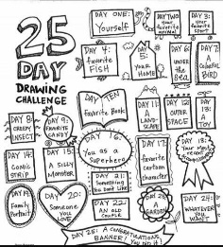

25 day drawing challenge
http://douglassimoes.co.za/project/25-day-2/

Indoor and outdoor scavenger hunts online

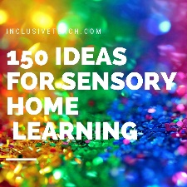
Sensory Learning ideas to try at home
https://inclusiveteach.com/2020/03/20/150-sensory-learning-ideas/

